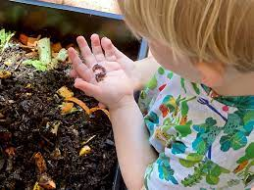

How to Compost with Kids?

Children will get more from the experience if they have their own compost container. A garbage can or plastic bin that is at least 3 feet (1 m.) tall and 3 feet (1 m.) wide is large enough to make compost. Drill 20 to 30 large holes in the lid and in the bottom and sides of the container to allow air in and let excess water drain through.  
  
A good compost recipe includes three types of ingredients:  
  
Dead plant material from the garden, including dry leaves, twigs, and sticks. Household waste, including vegetable scraps, shredded newspaper, tea bags, coffee grounds, eggshells, etc. Don’t use meat, fat, or dairy products or pet waste. A layer of soil adds earthworms and microorganisms that are necessary to break down the other materials. Add water now and then and stir the container weekly with a shovel or large stick. Compost can be heavy, so little ones may need help with this.